Joel T. Nadler
Learning the basic fundamentals and mechanics of handgun use and skills aiding self defense is best accomplished through directed training (classes). Although structured classes are a great way to learn, they should not be taken in a vacuum. The skills, methods, and techniques from each class need to be practiced. This series of posts is intended to provide a guide to practicing and reinforcing the fundamental skills needed for the safe and effective use of a handgun taught in the vast majority of handgun classes.
Safety
More than anything else, practice safety. Make sure you are being hyper-aware of muzzle discipline (always ensuring the muzzle of your gun is pointed in a safe direction) and trigger discipline (never placing your trigger finger inside the trigger guard or on the trigger unless you are on target (see muzzle discipline) and ready to shoot).
1) Treat every firearm as if it is loaded. Always!
2) Never point a firearm at anything you do not want to injure, damage, destroy (or purchase)
3) Keep your finger off the trigger, outside the trigger guard, and along the frame until you are on the target and intending to shoot
4) Be absolutely certain of your target and the environment. (Anything in line with the firearm and target)

Live-fire versus Dry-fire
Many of the fundamental skills needed to safely and effectively utilize a handgun can be practiced either life-fire (at a range with live ammunition) or dry-fire (anywhere utilizing a triple-checked handgun with all ammo removed).
Practicing the Fundamentals
Many shooters try to rush through this important series of basic skills (Basic Function, Stance, Grip, Sight Alignment, and Trigger Press), but they are called the fundamentals for a reason; mastery of these skills is the fundamental base of the safe and effective (accurate) use of a handgun. When top shooters are asked what they do when they are wanting to continue developing their skills, they inevitable report returning the fundamentals.
Basic Function (loading and Unloading)
Practice loading magazines as well as inserting the magazine in your gun (using dummy rounds dry and live rounds on the range). Primary skills to master are 1) the smooth and firm insertion of the magazine into you handgun every time, and 2) Smoothly and firmly drawing back and releasing the slide (making sure to let it go and not ride it forward). These skills should be practiced dry until they are automatic responses (requiring no to little effortful thought) and then reinforced live every time you are at the range. Note: do not forget safety (self-check your muzzle and trigger discipline every time you load and rack (make ready to fire/place into battery) your handgun. During these basic function skills is where we often see safety violations in newer shooters as the focus is on the action not safety (another reason to practice these skills until they become automatic). Remember if needed move your body around the gun (thus keeping it pointed down range) instead of moving the gun (and potentially pointing the muzzle in an unsafe direction) when doing basic functions like racking, loading, reloading, and malfunction clearances.
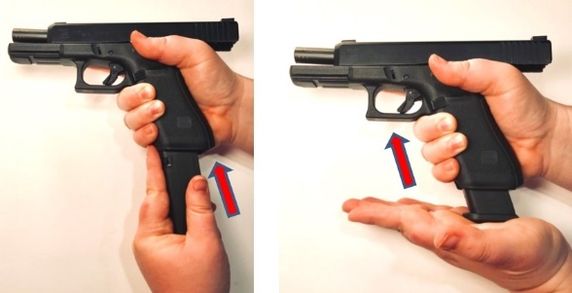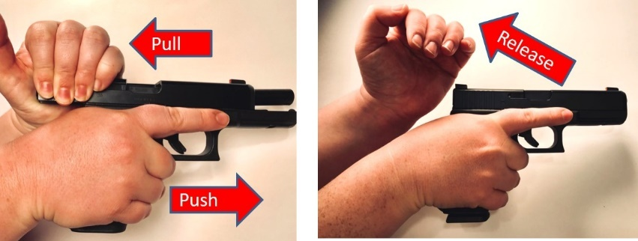
Stance
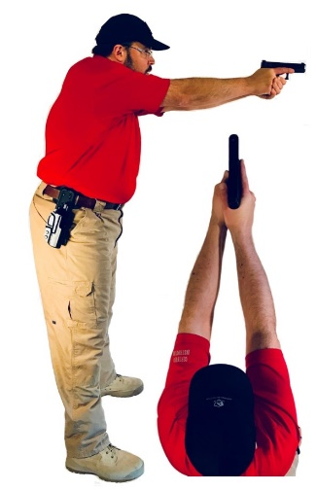
Practice a natural and neutral shooting platform (adjusted as necessary, but the goal is to consistently adopt a weight forward stance every time you are prepared to shoot).
Things to look for include; 1) natural shoulder width foot placement squared off facing the target (forming a triangle with your legs), 2) slight bend to the knees (ready to move), 3) both arms ‘punched’ out (forming a triangle with your arms), 4) bent slightly forward at the waist (weight forward, making sure you are not leaning back from the gun), and 5) raising the gun sights to your eye (gun up to the eye, not eye down to the gun (slumped down).
Systematically establish your proper shooting stance every time you practice dry or live fire (and spot check that you have maintained your stance throughout your practice. The goal is to consistently adopt the same stance every time you go to shoot.
Grip
Practice (systematically at first) adopting a ‘thumbs forward’ two handed grip. Make sure your dominant hand has the ‘V’ of the thumb and fingers high up on the grip and just below the tang of the back of the gun. Your dominant hand trigger (pointer) finger should be high on the frame and out of the trigger guard, the remaining three fingers should be wrapped around the front of the grip with the index finger high on the grip touching the bottom of the trigger guard. The dominant hand thumb should be out straight along the frame of the gun (not curled in to close the grip with the fingers). The dominant hand grip should be a firm handshake. The support hand grip should start with the palm of the support hand covering the exposed grip on the support hand side. All four fingers should be high on the front of the grip covering the fingers of the dominant hand (the pointer finger should be toughing the bottom of the trigger guard. The support hand should have a tighter grip (providing support).
Systematically work on your proper grip every time you dry or live fire with a goal of automatically adopting a proper and consistent grip every time you shoot. Spot check your grip during live fire practice to ensure you are maintaining your grip through the process of firing and recoil.
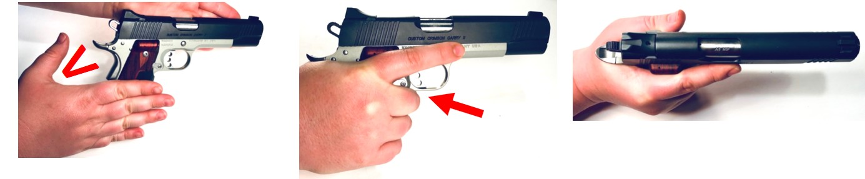
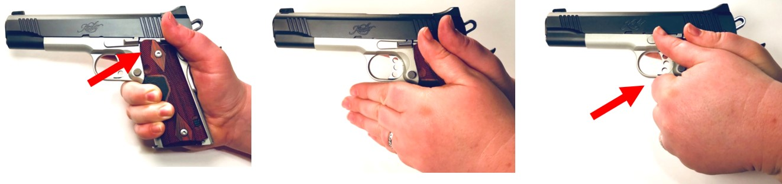
Sight Alignment
Practice focusing on the front sight and placing the front sight at equal height and equal light in the notch of the back sight. Think about a straight line going from your eye through the rear sight, front sight and on to your target (bringing the gun to your eye compared to the eye to the gun helps with this). Utilize your stance/ grip to naturally align the front sights into your field of vision. Accept there may be some ‘shake’ to your sight picture, this is natural. As long as you hold the gun level to your sight line this will only result in small variations in the point of impact of each bullet. Self-check that you are not lowering the gun as you shoot and give yourself the time you need to line up each shot. The goal is to consistently find your equal-height / equal-light sight picture every time your shoot and to regain it quickly after recoil. Watch out for shooting too quickly. Slow is smooth and smooth becomes fast.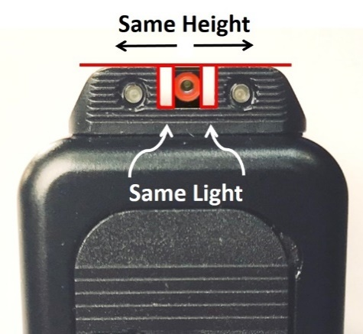 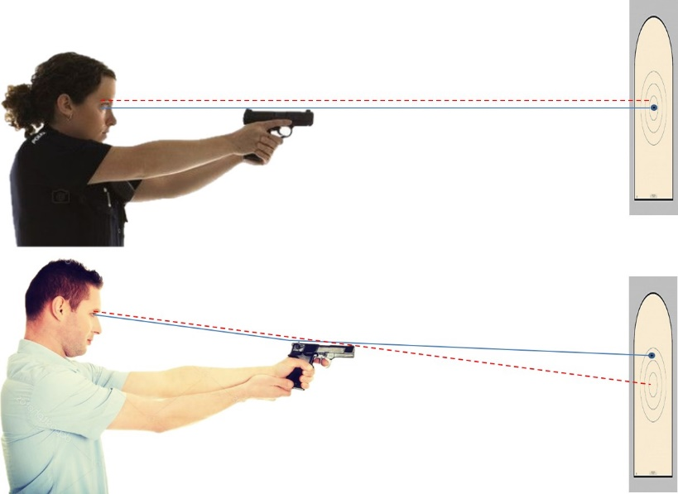
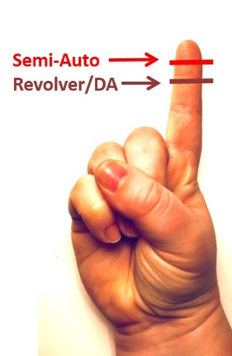
Trigger Press
Practice (and practice and practice) your trigger press. This is the culmination of all the other fundamentals (Stance, Grip, Sight Alignment). Make sure your finger is not too far in or not far enough (for most people the middle of the pad of the trigger finger. Your finger should be placed on the trigger allowing it to smoothly press the trigger back to the break point (where the gun fires) without twisting the front of the gun to either the right or left. You should press the trigger back slowly and consistently until the ‘break.’ The initial goal is to let the ‘break’ surprise you. Once the trigger breaks, practice not releasing the trigger through recoil and then slowly release the trigger only as far as needed to hit the reset (the ‘click’ letting you know the trigger has reset and then smoothly press the trigger back for the next shot.
The primary goal is to consistently and smoothly pressing the trigger without disturbing your sight picture and ‘surprising’ yourself with the break to reduce the likelihood of recoil anticipation or flinch. The secondary goal is to only release the trigger to the reset point each time you fire minimizing the distance needed to operate the trigger on each press. Once again slow is smooth and smooth becomes fast. Take the time to consistently operate your trigger each and every time.
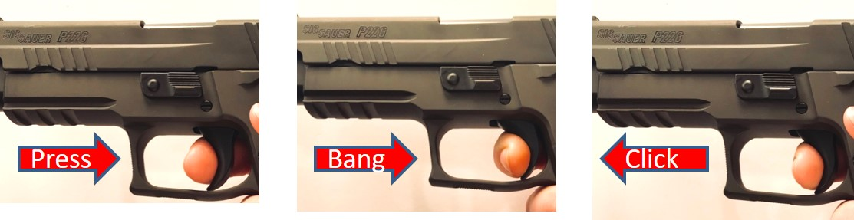
Using Speed and Distance
As you practice the fundamentals, remember most defensive encounters occur at 21 feet or closer, with many much closer. I suggest working on fundamentals at 9-15 feet when utilizing live fire at the range. As you master your fundamentals you should use the ‘fist sized group’ as your training metric. If you are consistently shooting a fist sized group adjust the speed (work on decreasing the time it takes for your initial shot and subsequent follow up shots) or use range (sending the target out further) to challenge yourself. When you hit a speed or range where you lose your fist sized group, practice until you can consistently bring your shots back to a fist sized group (at which point adjust your speed and distance again). Shooting smaller than fist sized group? Speed up or send that target out.
Note the development of a skill set is rarely a steady line of improvement. You may have to occasionally; 1) slow down, 2) bring the target closer, and/or 3) go back to systematically self-checking your fundamentals. The goal of each and every dry fire or live fire session is to further reinforce doing each of the fundamentals correctly and consistently. Though many range visits should be purposeful (practicing your skills and pushing your skill set) this does not mean not enjoying your time at the range, and there is plenty if room for recreational shooting, just make sure you are still practicing good form and the fundamentals.

