Fundamentals and Mechanics: Practicing what you learned, Part II
Joel T. Nadler
Last week I reviewed the fundamentals and how to consistently practice and self-coach those same skills in live and dry fire practice (If you haven’t check it out do so now, I’ll wait:). This entry will focus on some of the mechanics of shooting such as malfunction clearances and continuing to build a defensive skill set beyond the fundamentals.
Intermediate Skills
Although firearms instruction covers many skills; there are three core skills worth incorporating into your regular practice. As with the fundamentals the eventual goal is to automate these skills/tasks to the point where you no longer have to think about them to perform them.
Malfunction Clearance
Being able to clear a malfunction efficiently and quickly is a key skill. The majority of malfunctions can be simulated with dummy rounds or snap-caps (inert ammunition). Practice the required steps of clearing a malfunction in a semi-automatic handgun until it becomes automatic. When you get a ‘click’ instead of a bang and the slide is not locked back, your goal is to automatically conduct the Tap-Rack & Roll drill. As soon as you get a failure to fire, your support hand should come off the gun (keeping the gun pointed down range at your target. You should use the heal of your support hand to give an firm tap to the bottom of the seated magazine and then immediately move to an overhand grip of the back of the slide driving the ejection port side of the gun rolling toward the ground as your rack the slide (pull it fully back and then release).
The goal is to practice this malfunction clearance until it is your natural response to a failure to fire for any reason. If this procedure fails to return the gun to a firing condition conduct a ‘Type 3’ malfunction clearance (remove the magazine, rack the slide three times, return the magazine, and re-rack a round into the chamber).
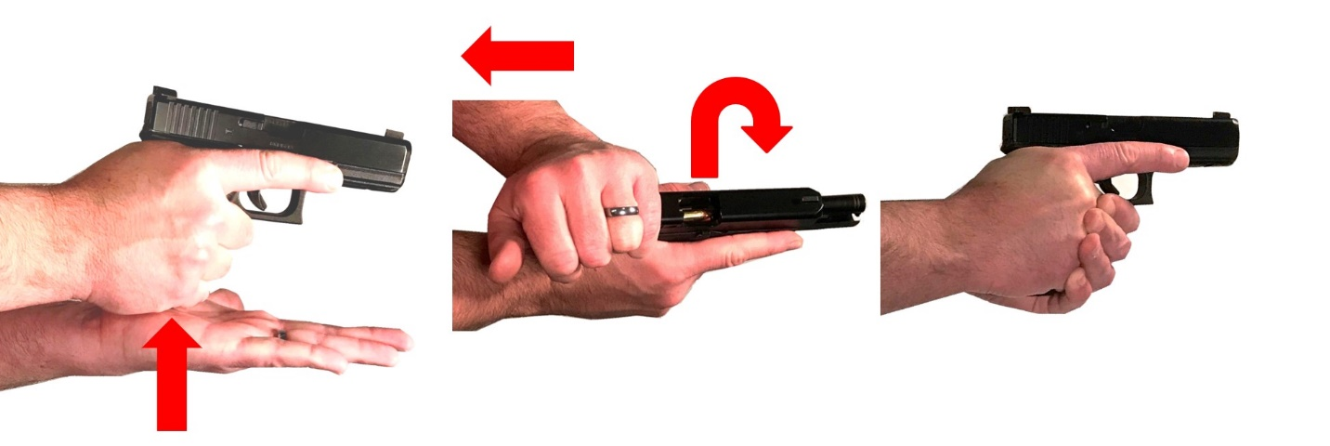

Getting of the line and scanning
Two other skills you want to make sure to ‘automate’ are initial movement (getting of the line of attack) and scanning (really looking around once an attack has been successfully stopped). Although, these motions may be constrained by the bays at many ranges you can still practice both skills. You want to practice taking a single step to the right or left prior to engaging your target and then once complete (you have fired the intended number of rounds take a single step in the other direction. The goal is to incorporate a short simple movement into your initial engagement of a threat and then follow the successful stopping of a threat with a similar simple movement. The goal is to automate these movements before and after any target is engaged.
Once the movement to the right or left after engaging a target is completed, practice scanning your environment. Really looks around to the left and right and behind. Note: you may need to release your support hand grip to look behind you as you need to maintain muzzle discipline throughout your scan. Make sure that every time you scan you find something to mentally note (a divot in the wall, read a word on the target system or sign, note what another person is wearing). This is to make sure you are practicing actually scanning and examining your environment and not just moving your head. We know from studies of self-defense shootings that we can easily miss large details (such as a second attacker) when under immediate stress.
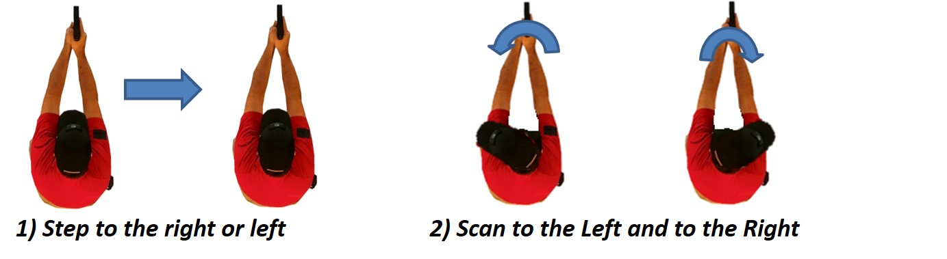
Reloading
If you would ever be in a situation where you would have access to a spare loaded magazine it is important to practice reloading on slide lock back. The natural response under stress to a handgun that stops working is confusion. Thus, we want to ‘automate’ the response of when the slide locks back we conduct the mechanics needed to get the gun back into a battery and ready to fire automatically. This takes practice. When your semi-automatic locks back (showing the gun’s magazine is empty, depress the slide release letting the magazine drop to he ground. Keeping the gun pointed down range, use your support hand to index (grab the magazine (stored bullets forward) with the index finger along the front of the magazine. With a smooth motion seat the new magazine in the magazine well of the gun and ‘snap’ the magazine into the gun with the heal of your support hand. With a full overhand grip, pull the slide fully back and release. Return your support hand to the grip and ‘punch’ back onto your target. If you carry an extra magazine on your person as a part of your everyday carry make sure you practice this reload from the position you carry (make sure you are carrying a spare magazine where you can safely access it and load the gun) and remember to check your muzzle discipline throughout the maneuver.
The eventual goal is to be able to reload automatically on slide lock without error, smoothly and efficiently, and without having to take your eyes off potential targets and threats. As with all practice, remember slow is smooth and smooth becomes fast.
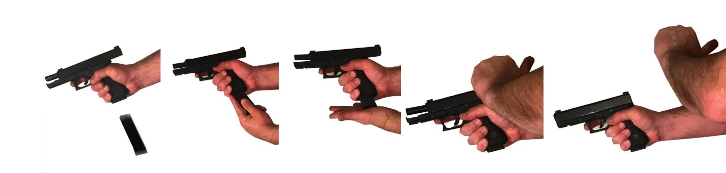
Putting it all Together on the range (Example 50 Round Practice Course of Fire)
Make sure you have sufficiently practiced the fundamental skills before adding intermediate skills to your practice routine. The following suggested practice session ‘Course of Fire’ will utilize all of these skills.
Load magazines with 50 live rounds incorporating at least one dummy round randomly placed in each magazine (reload magazine as needed). Once at the range orient your handgun with the muzzle pointed down range before removing it from the case in the stall. Make sure your extra magazines are located where they can be safely reached (behind the firearm).
Place a torso target at an appropriate range for your current abilities to get fist sized groups (note you may need to adjust the height of the target to make sure your center of mass and head shots will continue down range into the back stop).
Load your handgun and make ready (check your fundamentals (grip and stance before shooting; sight alignment and trigger press while shooting).
Before each engagement of the target decide on the number of rounds you will shoot and location (examples could include 1 to 3 rounds to the center of mass, 2 to 3 to the center of mass followed by a head shot, etc.).
Once you have decided begin one ‘set.’ A ‘set’ included 1) moving off the line one step to the left or right as allowed by the shooting bay, 2) engaging the target the decided number of rounds, 3) stepping back of the line with another simple single side step, and 4) Scanning your surroundings.
After completing a ‘set’ decide on another combination of rounds and repeat.
If you encounter a malfunction (dummy round) clear the malfunction and finish your intended rounds of the ‘set.’ So, for example if you decided to shoot 4 rounds center mass and got a ‘click on the third round, you would clear the malfunction and fire the remaining 2 shots of the ‘set.’
If the slide locks back, the ‘set’ is not over if you still have rounds to shoot, reload the gun and finish the ‘set.’
Complete 50 rounds using these drills and adjusting speed and distance to push your skills set getting fist sized groups. Remember slow is smooth and smooth becomes fast. It is far preferable to do these actions correctly slowly then to do them poorly quickly. Finally, always keep safety (muzzle and trigger discipline) as the primary goal of any practice session.

